- polski
- Nagrywanie
- Powiadomienia (0)
- Powiadomienia (0)

- Record Wizard
- Dyskusja
- Statystyki
- Zbiory danych
- Pomoc
- O Lingua Libre
Edytuj
Akcje

RecordWizard manual
Inne języki:
English • ‎Esperanto • ‎français • ‎日本語 • ‎occitan • ‎svenska

Spis treści
- 1 Tutorial
- 2 Speaker
  - 2.1 Spoken languages
  - 2.2 Licence options
- 3 Details
  - 3.1 You record your words in
  - 3.2 Submitting word(s)
  - 3.3 Shuffle list
- 4 Studio
  - 4.1 List on the left
  - 4.2 Keyboard shortcuts
- 5 Publish
  - 5.1 List of words
  - 5.2 Audio player
  - 5.3 Completion bar and word counter
  - 5.4 Navigation bar

Tutorial
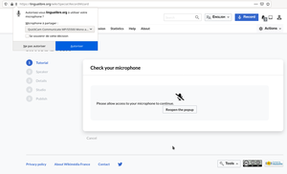
Allow the Record Wizard to access your microphone.
At this step, the Record Wizard checks whether your microphone works fine.
First of all, allow your web browser to access your microphone. If you did not allow the access, reload the page in order the web browser asks you again.
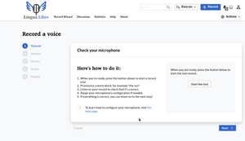
Tutorial step.
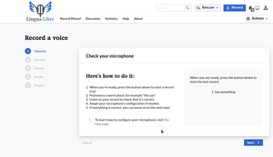
After clicking on "Start the test", the Record Wizard asks you to say something.
Click on the "Start the test", say something and listen to what you said. If you do not hear anything, configure your microphone.

Speaker
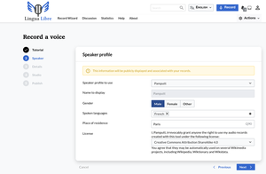
Speaker step.

Spoken languages
In this section you will be able to select the language(s) you are proficient in, but most importantly the language(s) in which you would like to record yourself.

Licence options
When getting to the licence selection section, you get five options, namely:
- Creative commons attributions ShareAlike 4.0
- Creative commons attributions ShareAlike 3.0
- CC0 1.0 Universal Public Domain Dedication
- Creative commons Attribution 4.0
- Creative commons Attribution 3.0
If you do not know about any of the different uses you can make out of these, then it is best if you let the default option "Creative commons attributions ShareAlike 4.0". However, if you wish to know more about how these licences diverge from each other, then this webpage might help.

Details
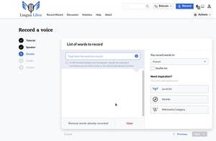
Details step.
In this section you will be able to submit the word(s) you would like to say aloud later.

You record your words in
There are several ways to get there, but first you will have to select the language you wish to register yourself in, among the list of languages you selected in your profile. If you only submitted one language in your profile then you don't need to make that choice.

Submitting word(s)
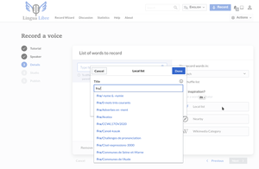
Clicking on "Local list" opens a popup.
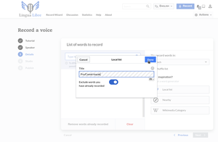
Click on the list you are interested in and validate by clicking on "Done".
These are the different ways to submit the word(s) you would like to pronounce. You can either:
- type your own word(s) directly in the blank space and adding as many as you want by clicking in the blue sum button that's next to it.
- In case you do not feel really inspired at that moment, you can reach out to the three methods Lingua Libre puts at your disposal in the bottom right corner, namely the "Local lists", "Nearby" and "Wikimedia Category":
  - Local lists: this feature enables you to use any list that has already been created by another user in Lingua Libre. In that case you will be able to uplaod the list by submitting its title behind the code that appears under the Title section. You should not erase that code but rather write the title after it.
  - Nearby: the following feature is based on the use of wikidata which locates your computer. You can enter your location in two ways: either by submitting it manually in case you know what latitude and longitude you find yourself in, or more simply by clicking on the position pictogram below. Wikidata will pull out accordingly a couple of words very closely related to your geographical position. There is no way however to adjust the miles around.
  - Wikimedia Category: the idea behind this is for you to submit a key word in the Category name section, and then a bunch of other words related to it will pop up, pulled out either from wikipedia or wikitionary, depending on which you select as a source. Additionally, there is also the option for you to select the number of those related words you wish to see in your recording list in the "Numbers of words to get" section.

Shuffle list
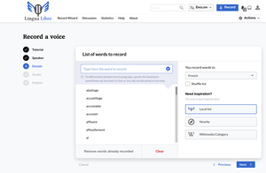
All the words you will record are listed on the left.
Once you have selected the list, if you do not like the order in which the words are set, then you can shuffle it by clicking on the Shuffle list button above the three features we have seen right above.

Studio
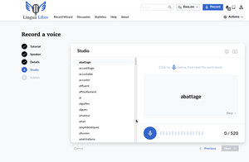
Studio step.
This is the step where you record the words that you have entered at the Details step. To start recording, click on the microphone button. Then pronounce the first word of the list. The Record Wizard will automatically pass to the next word to pronounce once it detects a blank.
If you want to stop recording, you can click on the Stop button
If you do not know how to pronounce a word, you can skip it and record the next one by clicking on the Skip button.
At any time, you can click on the "Next" button to publish all the words you have already recorded (even if you did not record all the words in the list).

List on the left
For each recording, if you click on one word, you can listen to it. In case the recording is not good, you can record it again or delete it by clicking on "circle arrow" button.

Keyboard shortcuts
- Left arrow: go back to the word you have just recorded
- Right arrow: pass to the next word without recording the current word
- Space key: play/pause
- Delete key: delete a recording

Publish
On the Publish screen, there are three parts :
- the list of words
- an audio player
- a navigation bar

List of words
Words are listed in the same order. Words which have not been recorded are not shown. Go back to the previous screen (Studio) to get the whole list back and record more audio from the list.
There is a vertical scrolling bar if the number of words exceed 14.
When you hover on a word, the line is highlighted but the word is not selected. Select one word to check the recording in the audio player on the right by clicking on the word. When selected, the word is highlighted in light-grey and a black triangle appears next to the word. This arrow is not a play button. The word is automatically played.
On the right side of each word, the tick box let you select which word you want to publish on Wikimedia Commons. The total number of words in the word counter updates accordingly.

Audio player
The word is displayed next to the audio player. By pressing on the left and right arrows, navigate and select the previous or the next word on the list.
The audio player is on the right side. Depending on the browser you are using, the audio player may look different.
- The recording can be played.
- The length of the recording is displayed in minutes and seconds. Usually, recordings are shorter than a second: the display may remain at 0:00.
- There is a small bar to navigate in the audio recording.
- The speaker icon change the volume of the audio player.
On Firefox, right click on the player to download the file, change the speed of the player, play the audio in a loop. On Edge, click on the three dots to open a menu to download the file on your device.

Completion bar and word counter
The word counter displays two numbers. The first number is the number of successful uploads to Wikimedia Commons. The second number is the number of words with a recording. This is not necessarily the number of words in the list of words defined in the previous screen.
When you pressed on the Publish button, a small waiting icon show up next the word being uploaded and under the word counter. When all recordings have been done, make sure every recording has been uploaded to Wikimedia Commons. The number of successful upload (on the left) should be equal to the number of recordings (on the right).
When there is an error on the upload of one or multiple recording, there is an exclamation mark below the word counter. Reupload by pressing retry failed upload button on the navigation bar.

Navigation bar
There are three buttons on the navigation bar.
- Click on Cancel to go back to the first screen (Tutorial). A confirmation window shows up. If you go back to the Tutorial screen, every recording not published yet will be lost.
- The Previous button brings you back to the fourth screen (Studio).
- The Publish on Wikimedia Commons button publish the recordings to Wikimedia Commons.
If there is an error during the upload of one or multiple recordings, the button :
- retry failed upload allows you to retry the upload of files to Wikimedia Commons.
If Internet connection is broken, try to re-establish a reliable internet connection and press the button.
After the audio recordings have been sent to Wikimedia Commons, new options replaced the buttons :
- Check your uploads on Wikimedia Commons is a link to the special page Special:ListFiles on Wikimedia Commons.
- Record more words brings you to the third screen (Details) to record more words. If some words of the same language were not recorded in the Studio screen, and did not appear in the Publish screen, they will show up again on the Details screen.
Kategoria:
- Lingua Libre:Help
- Tę stronę ostatnio edytowano 19 sty 2021, 17:50.
- Treść udostępniana na licencji Creative Commons 4.0 Attribution-ShareAlike, jeśli nie podano inaczej.
- Polityka ochrony prywatności
- O Wikimédia France
- Kontakt

- Narzędzia

